NERAHMS
c/o RifME
75 Two Lights Rd.
Cape Elizabeth, ME 04107

22nd Annual
NERAHMS
TRADE SHOW
Tuesday, October 4, 2011
Red Jacket Resort & Indoor Water Park
North Conway, NH

AGENDA

Monday, October 3, 2011

11:30 AM 6th Annual Scholarship
Golf Tournament
Registration
North Conway Country Club
North Conway, NH

12:30 PM Shot Gun Start

Tuesday, October 4, 2011

9:00 AM Vendors set-up begin

10:00 AM Opening General Session

12:00 PM Luncheon Buffet
with Vendor Access

1:00 PM Training Sessions w/
Vendors

2:30 PM Vendor Access

4:00 PM Cocktail Reception with
Vendors - Door Prizes

North East Regional
Association of Housing Maintenance Supervisors
NERAHMS
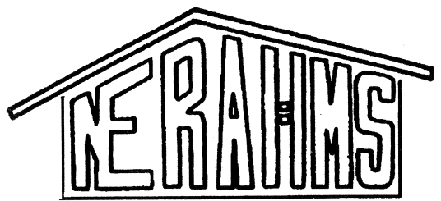
www.nerahms.org

22nd
2011
Trade Show
October 5, 2010
&
Conference
October 3 – October 6,
2011

Red Jacket Resort & Indoor Water Park
North Conway, NH

